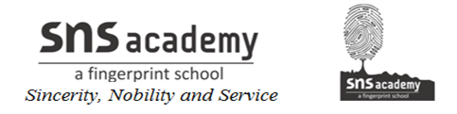

GRADE: IV B NAME:
DATE: 10.12.22 SUB: SOCIAL
13. WATER RESOURCES

